**Journal Section: Behavioral/Systems/Cognitive**

# Effects of transcranial alternating current stimulation on human BOLD responses during visual motion adaptation

Kohitij Kar, Jessica Wright, and Bart Krekelberg

**Correspondence To:**

Kohitij Kar

Center for Molecular and Behavioral Neuroscience

Rutgers University

197 University Ave

Newark, NJ 07102

E: [kohitij@vision.rutgers.edu](mailto:kohitij@vision.rutgers.edu)

**Number of figures:** 4

**Number of pages:** 16

**Number of words:** XX(abstract), XX(introduction), and XX(discussion)

## Keywords

Transcranial alternating current stimulation, fMRI, motion adaptation, mechanisms, BOLD, functional connectivity

## Conflict of Interest

A patent application has been ﬁled on subject matter disclosed in this manuscript.

## Acknowledgements

Research reported in this publication was supported by Eye Institute of the National Institutes of Health, USA under award number EY017605, the Charles and Johanna Busch Memorial Fund at Rutgers, The State University of New Jersey, and the Army Research Office (W911NF-14-1-0408). We thank Gregg Ferencz and Jasmine Seigel for excellent technical support. We also thank Melanie Arroyave, Sophia Chirayil and Heta Patel for assistance during data collection.

# Abstract

Transcranial alternating current stimulation (tACS) has been successfully used as a non-invasive tool for cognitive enhancement and clinical applications. But the underlying physiological effects of the externally applied electric fields during tACS are complex and are poorly understood in the intact brain. We have previously shown that tACS applied over the motion sensitive area hMT+ in humans, attenuates the aftereffects of visual motion adaptation. In addition, previous neuroimaging studies have also identified the consequences of direction selective motion adaptation on the human BOLD signal (functional magnetic resonance imaging adaptation, fMRIa) in human area MT (hMT+). Here, we have performed concurrent tACS and fMRI to directly investigate how the attenuation of motion adaptation by tACS is captured in the BOLD signal. We report that tACS reduces direction selective BOLD signal adaptation. tACS increases the BOLD signal during prolonged exposure to a moving stimulus, which suggests an increased activity in the underlying area, due to reduced adaptation. Furthermore, we also observe that tACS increases the functional connectivity between the stimulated and non-stimulated hemispheres during the presentation of a non-adapted, novel stimulus. Taken together these findings elucidate the mechanisms of tACS and provide a working hypothesis (attenuation of sensory adaptation) for the effects of tACS. Our study also demonstrates the potential use of concurrent tACS and fMRI in humans to investigate tACS mechanisms.

# Introduction

Transcranial alternating current stimulation (tACS) has been shown to modulate specific functionalities of human behavior when applied over the corresponding brain regions (Cohen Kadosh et al., 2010; Polania et al., 2012; Sela et al., 2012; Struber et al.). Although this approach has been very successful in establishing tACS as a potentially powerful neuromodulatory tool, research identifying the mechanisms by which it works is significantly lacking. This limits the optimal use of tACS. We intend to bridge this gap by testing neurophysiological predictions directly inferred from behavioral measures. We have previously shown that tACS applied over the parietal cortex in human subjects during a prolonged presentation of a visual motion stimuli, attenuated the subsequent motion aftereffect. Here we perform simultaneous fMRI and tACS to directly investigate the underlying neurophysiological consequences of tACS on the BOLD signal during motion adaptation.

Previous neuroimaging studies have identified distinct visual motion sensitive areas in the human cortex, hMT+ areas (Tootell et al., 1995). When human subjects are adapted to a prolonged presentation of motion stimulus at a specific direction, a subsequent presentation of motion in the opposite direction, results in a greater BOLD response in hMT+ than motion presented in the adapted direction (Huk et al., 2001). This asymmetry, or difference in the BOLD response, in turn has been suggested to account for the motion aftereffect (MAE). Given that we have previously found a tACS-induced attenuation in MAE, we hypothesized that the tACS will reduce this asymmetry, thereby reducing the measure of fMRI adaptation.

We found that when tACS was applied over left hMT+, it reduced the motion directive selective adaptation in the BOLD responses of the left hemisphere much more than that in the right hemisphere. During adaptation, tACS significantly increased the BOLD responses of the stimulated hemisphere. Furthermore, it increased the functional connectivity between the left and right hemisphere, when the motion direction presented was opposite to that of the adapter. Taken together, the previous behavioral findings and the BOLD response changes reported in this study, provide a novel mechanism for the action of tACS; reduction of motion direction selective adaptation.

# Methods

## Subjects

Ten subjects (5 female) participated in the study. Subjects gave written consent and all had normal or corrected to normal vision. This study was conducted according to the principles expressed in the Declaration of Helsinki and approved by the Institutional Review Board of Rutgers University.

## tACS

### Combined tACS and MRI set up

We combined transcranial electrical stimulation with MRI acquisition, which has previously been shown to be safe with minimal artifacts in MR images (Holland et al., 2011; Antal et al., 2012). However, one study has shown a reduction in the BOLD signal to noise ratio of 3 – 8 % (Antal et al., 2011). We followed setup similar to previous experiments (Antal et al., 2011; Holland et al., 2011). The stimulus generator was in the control room and connected to the MR compatible cables in the scanner room via a wall mounted connection equipped with a radio frequency (RF) filter (MRIRFIF, Biopac). We then connected the MR compatible cable to the electrode leads. A shielded cable (custom CBL200, Biopac) was used to connect to the stimulation electrodes. It was equipped with a 5.6 kOhm resistor at the end (near the subject’s head) to avoid sudden temperature increases due to induction voltages from RF pulses. We placed each lead in a plastic covering to avoid overlapping wires and loops to prevent current induction (Brocke et al., 2008; Stagg et al., 2009), and passed these leads out the side of the head coil and along the bore towards the back of the scanner.

### Electrode Placement and stimulation parameters

We applied tACS using an STG4002 stimulus generator (Multi Channel Systems, Reutlingen, Germany). The stimulating electrodes were prepared as conductive gel (Signa) applied onto conductive rubber electrodes (7.6 cm diameter). One electrode was placed above the canonical location of left hMT+; PO7-PO3 in the 10-20 system. The other electrode was placed on the vertex (Cz). The current intensity was 0.5 mA, frequency of tACS was 10 Hz and the electrode surface area was 45.6cm2.

## Visual Stimulus

### Stimulus Generation

A Canon REALiS SX80 Mark II LCOS projector back-projected the stimuli onto a screen located at the end of the MRI bore at a refresh rate of 60 Hz. Subjects viewed the stimuli via a mirror attached to the head coil. The combined distance of the screen to the mirror and the mirror to the subjects’ eyes was 103 cm. The display measured 22° (width) by 12° (height) and had a resolution of 1920 x 1080 pixels. Stimulus presentations and the triggering of stimulation were under the control of Neurostim (<http://neurostim.sourceforge.net>).

### Eye movements

All eye movements were monitored and recorded using an eye tracker (Eyelink II V 2.2) at 500 Hz. No trials were aborted online based on eye position.

### Motion adaptation paradigm

We used the visual motion adaptation paradigm from Huk et al. (2001) to quantify direction selective motion adaptation in the BOLD signal. Subjects fixated a dot at the center of the screen while we presented two moving gratings on either side of the dot. For each experimental run, both gratings initially moved inward for 30s (l*ong adapter*). Subsequent trials were classified into two conditions. During *opposite direction trials* a top-up adapter (both gratings moving inwards for 4s) was followed by a test stimulus moving outward for 0.5 s. During *adapted direction trials* the adapter was followed by a test stimulus moving inward for 0.5 s. The sequence of trials (i.e., after the initial 30 s *long adaptation)* alternated between three opposite direction trials and three adapted direction trials. We define these 6 trials as one block. Each block was presented 7 times. We had four experimental runs in total. During the first two, tACS was not turned on. For the last two runs, tACS was applied over the left hMT+ whenever the adapter (both *long adapter* and the top-up adapter) stimulus was on the screen (i.e., during the induction of adaptation).

The functioning of area hMT+ is lateralized, that is, the right hemisphere responds primarily to stimuli presented in the left visual field and vice versa (Dukelow et al., 2001). This allowed us to perform control experiments to assess the selectivity of tACS and exclude a number of potential confounds. We applied tACS only on the left hemisphere. Therefore any tACS-induced cortical effect is likely to be biased towards the left hemisphere.

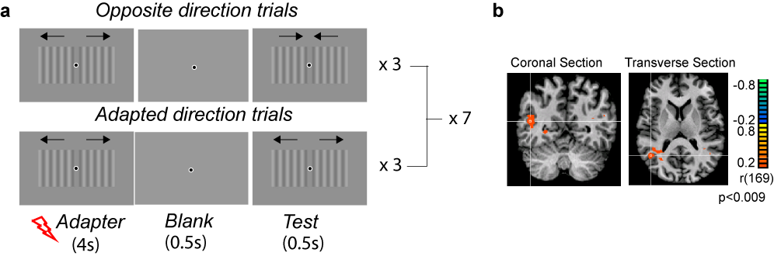

**Figure 1.** Experimental paradigm and results from representative example subject.

## fMRI

### Data Acquisition

We conducted all imaging at the Rutgers University Brain Imaging Center (RUBIC) using a 3T MRI (Tim Trio, Siemens) scanner. We placed the subject’s head in a 32-channel head coil with padding around the head to minimize movement. We used a T1-weighted MPRAGE sequence to collect high resolution (voxel resolution = 1 mm3) anatomical images from each subject. For functional scans, we used a T2*-weighted echo planar imaging sequence (repetition time = 2000 ms, echo time = 25 ms, flip angle = 90°, matrix = 64 x 64). The 35 slices (in plane resolution = 3 x 3 mm; slice thickness = 3 mm) covered the entire brain and were oriented approximately parallel to the anterior commissure and posterior commissure (ACPC) line.

### Data Preprocessing

We analyzed the fMRI data with BrainVoyager (version 2.6) software package (Brain Innovation, Maastricht, Netherlands) and MATLAB (MathWorks). We discarded the first nine volumes of each functional scan. We then preprocessed the functional data. This included a linear trend removal, slice scan time adjustment, 3-D motion correction with alignment to the first volume within an MRI session and temporal filtering using a high-pass fast Fourier transform filter with a 0.0078 Hz cut-off. The functional images were superimposed on the high-resolution 2D anatomical images and incorporated into the 3D data sets through trilinear interpolation. The complete data set was transformed into Talairach space.

** NOTE** Should I include the preprocessing I performed in AFNI for the functional connectivity, since it was done from scratch?

For functional connectivity analyses, fMRI preprocessing was performed using AFNI (version 2011-12-21) (Cox 1996). EPI images were slice-time corrected, aligned to the subject’s skull-stripped MPRAGE in native space, motion-corrected, and transformed to Talairach space. A linear regression was subsequently performed to remove nuisance parameters from the time series: six motion parameters, ventricle and white matter time series along with their derivative time series, binary task timings convolved with a canonical hemodynamic response function to the opposite, same, and long adapt trials separately, and binary timings for tACS onset. The residual time series was then spatially smoothed within a one-voxel dilated gray matter mask at 6mm FWHM.

## Data Analysis

### ROI Analysis

We defined area hMT+ by a sphere (10 mm radius) around the Talairach coordinates (40,-60, 0) for the right hemisphere and (-40,-60, 0) for the left hemisphere.

To generate the predicted BOLD time course, we convolved the timing of the *opposite direction trials* with a two-gamma hemodynamic response function (HRF, onset = 0 s, response to undershoot ratio = 6, time to response peak = 5 s, time to undershoot peak = 15 s, response and undershoot dispersion = 1). The strength of direction selective fMRI adaptation for each corresponding voxel in the ROI was quantified as the linear (Pearson) correlation between the predicted BOLD time course and the fMRI time course of the voxel. Therefore, a positive correlation indicates voxels that have an increased BOLD signal during the opposite direction trials compared to the adapted direction trials.

### Functional Connectivity

We performed a seed-based functional connectivity analysis, using the two spherical area hMT+ ROIs (defined above) as seeds. The average time series of each seed were extracted and subsequently correlated with every voxel in the brain separately for either the tACS on time series or the tACS off time series, resulting in four separate connectivity maps (two tACS condition multiplied by two seeds). Four t-tests were performed on the resulting connectivity maps: (1) stimulated left hMT+ versus stimulated right hMT+ connectivity, (2) non-stimulated left hMT+ versus non-stimulated right hMT+, (3) stimulated left hMT+ versus non-stimulated left hMT+, (4) stimulated right hMT+ versus non-stimulated right hMT+. Significant cluster size was computed using AFNI’s 3dClustSim with 10,000 Monte Carlo simulations using p < 0.01 as the uncorrected threshold and a smoothing parameter of 6mm FWHM. For a corrected p < 0.05, the cluster size was computed to be greater than 37.8 voxels.

# Results

We measured the influence of tACS (±0.5mA, 10 Hz), on motion direction selective fMRI adaptation.

## tACS reduces direction selective motion adaptation

We measured the strength of the direction selective adaptation of the BOLD response (see Methods). Figure 1b shows the data from one example subject. The white cross hairs in the coronal and the sagittal slices are at the Talairach coordinates x = 40, y= -72, z = -7. The red clusters show the voxels that were significantly adapted. The absence (or lesser quantity) of these clusters on the left hemisphere (shown in the right side of the image, neurological convention) shows that it is less adapted than the right hemisphere. At the population level, Figure 2a shows a comparison of the BOLD adaptation at the left (stimulated) versus right (non-stimulated) hemisphere, for each subject. We found that BOLD responses in the left hemisphere were significantly less adapted (Wilcoxon sign rank test; p<0.05). Figure 2b shows the comparison of the difference in adaptation between the two hemisphere per block, with (solid bold curve) and without (solid thin curve) tACS. We compared these changes induced by tACS with a three-way repeated measures ANOVA with factors of block (1-7), hemisphere (left/right) and tACS (ON/OFF). The main effect of tACS was significant (F(2,1) > 1000; p<0.001). The interaction between tACS and hemisphere was also significant. (F(2,1) = 5; p<0.05). Figure 2c shows further explains these results.

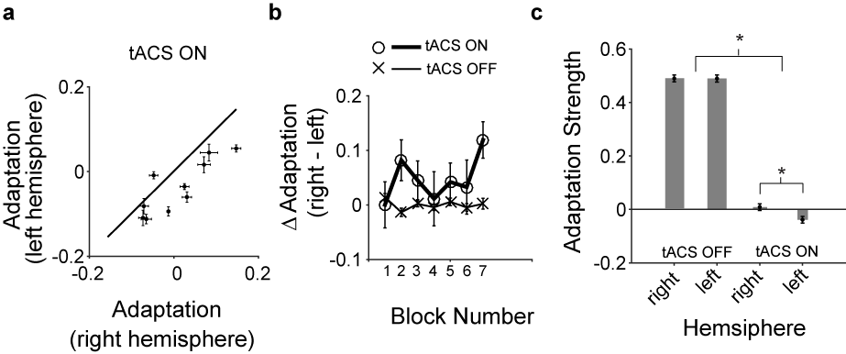

**Figure 2.** tACS attenuates BOLD adaptation in a hemisphere specific way.

## tACS increases BOLD response during stimulation

A reduction in adaptation can be reflected in the neural population activity in multiple ways, giving rise to testable predications. First, if tACS down regulates the neural activity, it could then lead to a lower overall adaptation. Second, if tACS disrupts the induction of adaptation mechanisms, then it might lead to increased activity levels, due to lack of adaptation. We tested these hypotheses by the comparing the BOLD response in the hMT+ ROI during the *long adapter* stimulus. Figure 3 shows the effects of tACS on the normalized BOLD response during the long adaptation period (see Methods). tACS increased the BOLD response during presentation of the long adapter. The effect was particularly strong at the left (stimulated) hemisphere (compare Figure 3a and 3b). We performed a three way repeated measures ANOVA with time (2 – 30 s), hemisphere (left/right) and tACS (ON/OFF) as the factors. There was a main effect of tACS (increase in BOLD response; F(2,1) = 7.8, p = 0.02). However, the interaction between tACS and hemisphere was not statistically significant.

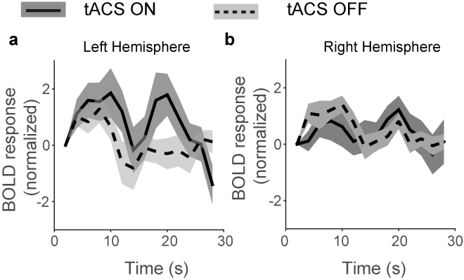

**Figure 3.** Effects of tACS on BOLD signal during long adaptation.

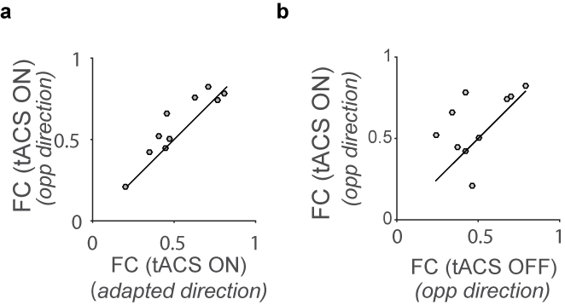

**Figure 4.** Effects of tACS on functional connectivity between the stimulated and non-stimulated hemisphere.

## tACS increases task-dependent functional connectivity

tACS increased the functional connectivity (FC) between the stimulated (left) and non-stimulated (right) hemispheres. We performed a two way repeated measures ANOVA to investigate how FC between the left and right hMT+ is affected by the two factors, tACS (ON/OFF) and trial type(adapted direction/ opposite direction) to test the . We observed a significant increase in FC with tACS (main effect of tACS; F(1,1) = 12.04 , p =0.007 ). We did not find any significant interaction in the ANOVA analysis. However, we observed that when tACS was applied, FC significantly increased (Wilcoxon signed rank test; p<0.05) for the *opposite direction trials* (Figure 4a) compared to the *adapted direction trials*. This increase could be caused either by a tACS-induced reduction in FC during the adapted-direction trials or a tACS-induced increase in the *opposite direction trials.* Figure 4b shows that this increase was due to a tACS–induced increase in the FC during the opposite direction trials (Wilcoxon signed rank test; p<0.05).

# Discussion

We investigated the BOLD signal changes in area hMT+ in human subjects with simultaneous tACS applied during motion adaptation. We found that tACS reduced fMRI BOLD adaptation. We also observed that the application of tACS increases functional connectivity between the stimulated and non-stimulated hemispheres. This increment was due to a specific increase in functional connectivity during the *opposite direction trials.*

We first address some of the confounding factors and limitations in the interpretation of our data. Then we speculate on the neural mechanisms that might be responsible for the tACS-effects we reported, and conclude with a brief discussion of the implications of our findings for the future use and interpretation of tACS-effects.

## Confounding factors

### Phosphenes

Application of tACS produces phosphenes via retinal stimulation (Schutter and Hortensius, 2010; Kar and Krekelberg, 2012; Laakso and Hirata, 2013). The phosphene can act as a distractor and therefore reduce attention during the motion adaptation task. The difference in adaptation between the left (stimulated) and right (non-stimulated) hemisphere control for this confound. We observe that attenuation of fMRI adaptation is larger for the left compared to the right hemisphere. This confirms that the effect is tACS-driven-cortically-induced and not a side effect of perceiving phosphenes.

### Artifacts introduced by tACS in the scanner

Transcranially applied electric fields in the MRI scanner has been previously reported to produce changes maximally in the EPI signal on the scalp and the CSF (Antal et al., 2012). Our experimental control design takes these observations into account. An increased or decreased BOLD response due to the artifacts, do not change the interpretation of our data. tACS was applied simultaneously during the adapter stimulus both for the *adapted direction trials* and the *opposite direction trials*. Hence the changes in adaptation as reported in this study cannot be biased by or attributed to tACS-induced imaging artifacts.

### Interhemispheric interactions

A possible crosstalk between area hMT+ of the two hemispheres through the corpus callosum and its functional significance has been previously proposed {Genc 2011}. Our stimulus was present in both the visual hemifield. Hence both the left and right hMT+ were simultaneously driven by the visual stimulus. We speculate that a reduction in adaptation in the left hMT+ produced by the direct influence of tACS might drive the effects on the right hMT+. The increase in functional connectivity during the *opposite direction trials* hint further towards this speculation. In our previous study (Kar and Krekelberg, 2014), we did not use a bilateral stimulus presentation. Given that the ipsilateral control experiment (Kar and Krekelberg) did not have any effect on motion adaptation, we speculate that the presence of a visual stimulus in both hemifield is necessary to elicit any significant inter-hemispheric effect.

## tACS mechanism

We have previously shown two distinct behavioral effects of 10 Hz tACS, applied over the parietal cortex, during presentation of a visual motion stimulus. First, it improved motion direction discrimination sensitivity. This led us to speculate that tACS might prevent the loss of sensitivity due to motion adaptation by attenuation adaptation, and thereby improving sensitivity. Indeed, further experiments showed that tACS reduced the adaptation induced motion aftereffect. Here we have investigated the neurophysiological changes that underlie the attenuation of adaptation. Our results (Figure 3a) suggest that tACS disrupts adaptation and likely increases the firing rate of the cells during adaptation. Hence, we have demonstrated that the behavioral effect is consistent with the tACS-induced changes in BOLD responses during motion direction selective fMRI adaptation. Taken together, this strongly suggests that tACS interferes and likely disrupts the induction of sensory adaptation in the brain. In addition, this is not due to a tACS-induced reduction in the activity of the area, rather an increase in population activity upon tACS. However, these results don’t allow us to derive at a unique prediction as to how tACS might reduce adaptation at a cellular or network level. First, the electric field induced by tACS is not limited to the area directly underneath the electrode (Datta et al., 2008; Kar and Krekelberg, 2012). Therefore it is difficult to predict whether the behavioral effects of tACS originate at any specific brain region. However, given that tACS specifically attenuated motion adaptation, both behaviorally and in terms of BOLD responses, we propose a cellular mechanism of tACS. Contrast adaptation in the cat visual cortex has been previously attributed to the recruitment of an intrinsic membrane hyperpolarization (Sanchez-Vives et al., 2000b). This adaptation-induced hyperpolarization of the membrane potential was mainly attributed to sodium and calcium dependent potassium currents (Sanchez-Vives et al., 2000a). We speculate that the membrane voltage fluctuations produced by tACS directly interacts with the dynamics of the Na+ and Ca2+ activated K+ channels, thereby reducing the after effect of adaptation. This hypothesis can be explicitly tested in vitro Specific genes termed slick and slack genes have been identified that encode for these sodium activated potassium channels (KNa) (Sanchez-Vives et al., 2000). Recently mouse visual cortical cells have been shown to exhibit adaptive properties like that of the macaques and cats (Stroud et al., 2012). Future studies can utilize slick and slack knockout mice to test how the lack of these genes modify the efficacy of tACS. . A previous study has reported that even small (<2mV) membrane voltage fluctuations reduce spike frequency adaptation in rat hippocampal CA1 neurons (Fernandez et al., 2011) by specifically interfering with Na+ channel de-inactivation. This can also be a possible candidate to account for the tACS induced effect.

## Conclusion

Our results show that tACS when applied during prolonged visual stimulation reduces the effects of adaptation. It also increases the overall activity in the area during the adaptation phase. This provides a mechanistic explanation for the action of tACS. We speculate that the cognitive enhancements reported {cite} using tACS might be a direct consequence of this increased overall responsivity of an area. However, the enhancement for one functionality might come at a cost of other cognitive functions {Luculano 2013}. Hence, a more detailed cellular level description of tACS mechanism is necessary.

# References

Antal A, Polania R, Schmidt-Samoa C, Dechent P, Paulus W (2011) Transcranial direct current stimulation over the primary motor cortex during fMRI. NeuroImage 55:590-596.

Antal A, Bikson M, Datta A, Lafon B, Dechent P, Parra LC, Paulus W (2012) Imaging artifacts induced by electrical stimulation during conventional fMRI of the brain. NeuroImage 85:1040-1047.

Brocke J, Schmidt S, Irlbacher K, Cichy RM, Brandt SA (2008) Transcranial cortex stimulation and fMRI: electrophysiological correlates of dual-pulse BOLD signal modulation. NeuroImage 40:631-643.

Cohen Kadosh R, Soskic S, Iuculano T, Kanai R, Walsh V (2010) Modulating Neuronal Activity Produces Specific and Long-Lasting Changes in Numerical Competence. Current biology : CB 20:2016-2020.

Datta A, Elwassif M, Battaglia F, Bikson M (2008) Transcranial current stimulation focality using disc and ring electrode configurations: FEM analysis. Journal of neural engineering 5:163-174.

Dukelow SP, DeSouza JF, Culham JC, van den Berg AV, Menon RS, Vilis T (2001) Distinguishing subregions of the human MT+ complex using visual fields and pursuit eye movements. J Neurophysiol 86:1991-2000.

Holland R, Leff AP, Josephs O, Galea JM, Desikan M, Price CJ, Rothwell JC, Crinion J (2011) Speech facilitation by left inferior frontal cortex stimulation. Curr Biol 21:1403-1407.

Huk AC, Ress D, Heeger DJ (2001) Neuronal basis of the motion aftereffect reconsidered. Neuron 32:161-172.

Kar K, Krekelberg B (2012) Transcranial electrical stimulation over visual cortex evokes phosphenes with a retinal origin. J Neurophysiol 108:2173-2178.

Kar K, Krekelberg B (2014) Transcranial Alternating Current Stimulation Attenuates Visual Motion Adaptation. J Neurosci 34: 7334-7340.

Laakso I, Hirata A (2013) Computational analysis shows why transcranial alternating current stimulation induces retinal phosphenes. Journal of neural engineering 10:046009.

Polania R, Nitsche MA, Korman C, Batsikadze G, Paulus W (2012) The Importance of Timing in Segregated Theta Phase-Coupling for Cognitive Performance. Current biology : CB.

Sanchez-Vives MV, Nowak LG, McCormick DA (2000) Cellular mechanisms of long-lasting adaptation in visual cortical neurons in vitro. The Journal of Neuroscience : the official journal of the Society for Neuroscience 20:4286-4299.

Schutter DJ, Hortensius R (2010) Retinal origin of phosphenes to transcranial alternating current stimulation. Clin Neurophysiol 121:1080-1084.

Sela T, Kilim A, Lavidor M (2012) Transcranial alternating current stimulation increases risk-taking behavior in the balloon analog risk task. Front Neurosci 6:22.

Stagg CJ, O'Shea J, Kincses ZT, Woolrich M, Matthews PM, Johansen-Berg H (2009) Modulation of movement-associated cortical activation by transcranial direct current stimulation. Eur J Neurosci 30:1412-1423.

Struber D, Rach S, Trautmann-Lengsfeld SA, Engel AK, Herrmann CS (2014) Antiphasic 40 Hz oscillatory current stimulation affects bistable motion perception. Brain Topography 27:158-171.

Tootell RBH, Reppas JB, Kwong KK, Malach R, Born RT, Brady TJ, Rosen BR, Belliveau JW (1995) Functional analysis of human MT and related visual cortical areas using magnetic resonance imaging. J of Neuroscience 15:3215-3230.